SIMATS ENGINEERING (SAVEETHA SCHOOL OF ENGINEERING)
Department of Computer Science and Engineering
CO1 ASSESSMENT TOOL 2 – Agile Sprint Planning & User Story Workshop
Course Code: | CSA10 / CSA1004 | Course Title: | Software Engineering
CO Assessed: | CO1 | Assessment: | Assessment Tool 2 – Agile Sprint Planning & User Story Workshop
Weightage: | 20% | Total Marks: | 25
CO1 Statement: | Apply advanced methodologies and agile project management techniques to manage software projects effectively
Student Name: | Amburi Manasa | Reg. No.: | 192372311
Date: | 10.10.2026 | Duration: | 60 minutes

Code of Conduct
I Amburi Manasa/192372311 (Name/RegNo) certify that this submission is my original work and that I have adhered to the guidelines specified for this assessment. I understand that any violation of academic integrity rules will result in disciplinary action.
Signature of the Student: Amburi Manasa

Annexure A – Agile Sprint Planning & User Story Workshop
Instructions to Students:
Each student is assigned an individual software project problem statement. Based on the given problem statement, perform an Agile Sprint Planning and User Story Workshop by applying Agile software engineering practices. Prepare a comprehensive sprint planning document covering the following aspects:
1. Identify the Project Vision and Stakeholders
- Define the project's vision, objectives, and identify all key stakeholders involved.
2. Create Epics and User Stories
- Break down the requirements into Epics and formulate well-structured User Stories using the format: As a <user>, I want <feature>, so that <benefit>.
3. Define Acceptance Criteria
- Write clear and measurable acceptance criteria for each selected user story using the Given–When–Then format or equivalent.
4. Prioritize the Product Backlog
- Organize and prioritize the product backlog based on business value, customer needs, and project dependencies.
5. Plan the Sprint Backlog
- Select high-priority user stories for the first sprint and divide them into actionable development tasks.
6. Estimate Effort Using Story Points
- Assign story points to each selected user story using an appropriate estimation technique (e.g., Fibonacci sequence or Planning Poker) and justify your estimates.
7. Present the Sprint Goal and Expected Deliverables
- Define a clear sprint goal and describe the expected sprint deliverables, including the features to be completed at the end of the sprint.
PROJECT: INTELLIGENT TRAFFIC VIOLATION MANAGEMENT SYSTEM
1. PROJECT VISION AND STAKEHOLDER IDENTIFICATION
1.1 Project Vision
The vision of the Intelligent Traffic Violation Management System is to provide a single, integrated digital platform that helps urban traffic authorities monitor roads, detect traffic violations, and process them quickly and fairly. The system combines camera-based monitoring, violation detection, evidence storage, vehicle identification, electronic notice generation, violation histories, and traffic analytics. By maintaining consistent records in one place, it aims to reduce dependence on manual enforcement, provide wider coverage, speed up violation processing, and support accurate decision-making.
The system is intended for use by city traffic police departments and transport authorities that need coordination between enforcement officers, control-room operators, vehicle-registration databases, and administrators. Intelligent features may include automatic detection of signal jumping, overspeeding, illegal parking, and lane violations, capture of image or video evidence, matching of vehicles to registered owners, and dashboards that summarize violation trends and hotspots. Authorized officers remain responsible for reviewing doubtful detections, correcting exceptional cases, approving notices, and protecting personal and vehicle information.
1.2 Project Objectives
- Monitor traffic using cameras.
- Detect predefined traffic violations such as signal jumping, overspeeding, illegal parking, and lane violations.
- Record violation evidence including images, video clips, location, and time.
- Identify vehicles associated with violations.
- Generate electronic violation notices.
- Maintain violation histories for vehicles and owners.
- Provide traffic violation analytics for traffic authorities.
- Support authorized administrative actions such as review, correction, cancellation, and appeals.
1.3 Key Stakeholders and Their Roles
The main stakeholders are traffic authorities and police departments, traffic enforcement officers, control-room operators, vehicle owners and drivers, transport and vehicle-registration departments, payment and fine-collection staff, legal or appeals officers, system administrators, and the software development team. Traffic authorities define violation rules, penalties, and enforcement policy. Control-room operators monitor camera feeds and review detected violations. Enforcement officers verify evidence and approve notices. Vehicle owners receive notices, view evidence, and pay or contest fines. The vehicle-registration department supplies vehicle and owner details. Payment staff record fine payments and resolve payment queries. Legal officers handle appeals and disputes. System administrators manage user access, backups, camera integration, and security, while developers test, maintain, and improve the application.
Each stakeholder has different access permissions. For example, control-room operators should see camera feeds and violation evidence, but should not edit penalty rules or access payment details. Managers and authorities may view summarized analytics, while owner details and evidence should only be available to authorized personnel. This role-based access reduces accidental changes and protects confidential information.
2. EPICS AND USER STORIES
Epics represent broad areas of functionality. Each epic is divided into smaller user stories that can be developed, tested, and delivered during a sprint.
2.1 Epics
- Epic 1 – Camera Monitoring and Violation Detection: monitor traffic feeds and detect predefined violations.
- Epic 2 – Evidence and Vehicle Identification: store evidence and identify the vehicle involved.
- Epic 3 – Electronic Notices and Fines: generate, send, and track violation notices and payments.
- Epic 4 – Violation History and Records: maintain centralized violation records for vehicles and owners.
- Epic 5 – Analytics and Reporting: provide violation statistics, trends, and hotspot reports.
- Epic 6 – Administration and Access Control: manage users, rules, reviews, appeals, and audit logs.
2.2 User Stories
- US1 – As a control-room operator, I want to monitor camera feeds and see detected violations, so that I can review events without watching every road manually.
- US2 – As an enforcement officer, I want the system to record image or video evidence with time and location, so that each violation can be verified.
- US3 – As an enforcement officer, I want the system to identify the vehicle from its registration number, so that the violation is linked to the correct owner.
- US4 – As a traffic authority, I want to define violation types and penalty rules, so that detection and fines follow official policy.
- US5 – As a vehicle owner, I want to receive an electronic violation notice with evidence, so that I understand the violation and can pay or contest it.
- US6 – As an administrator, I want to review, correct, or cancel a violation record, so that wrong detections are handled properly.
- US7 – As a traffic manager, I want to view violation analytics, so that I can plan enforcement and improve road safety.
3. ACCEPTANCE CRITERIA
Acceptance criteria define the conditions that must be satisfied before a user story is considered complete. They are written in a testable Given–When–Then format.
- US1 – Monitoring: Given an active camera feed, when a predefined violation is detected, then the system creates a violation event with camera ID, time, and violation type, and displays it in the operator's review list within the agreed response time.
- US2 – Evidence: Given a detected violation, when the event is saved, then the system stores the image or video clip with time, date, and location, and the evidence cannot be modified by unauthorized users.
- US3 – Vehicle identification: Given a clear vehicle image, when the registration number is read, then the system matches it with the vehicle database and shows the owner details. If the number is unclear or not found, it flags the record for manual review.
- US4 – Rules: Given an authorized authority user, when a violation type and penalty are saved, then the rule is applied to new violations and the change is recorded in the audit log.
- US5 – Notice: Given a verified violation linked to a vehicle, when the notice is generated, then it has a unique notice number, violation details, evidence reference, fine amount, and due date, and is sent to the owner's registered contact.
- US6 – Administrative action: Given an existing violation record, when an authorized officer corrects or cancels it with a reason, then the new status, officer name, and time are recorded and visible to authorized users.
- US7 – Analytics: Given valid violation records for a selected period, when a manager opens the dashboard, then the system displays violation counts by type, location, and time, with the selected date range.
4. PRODUCT BACKLOG PRIORITIZATION AND SPRINT PLANNING
4.1 Prioritized Product Backlog
The product backlog is ordered by business value, urgency, dependencies, and risk. The MoSCoW approach is used: Must Have items are essential for the first usable release; Should Have items are important but can follow; Could Have items improve convenience; and Won’t Have items are excluded from the current release.
Priority | Backlog Item | Reason | Planned Release
Must Have | Violation detection and event creation | Core function; everything else depends on it | Sprint 1
Must Have | Evidence recording | Required for legal verification of violations | Sprint 1
Must Have | Vehicle identification | Links each violation to the correct vehicle | Sprint 2
Should Have | Violation rules and penalty setup | Ensures fines follow official policy | Sprint 2
Should Have | Electronic notice generation | Speeds up processing and owner communication | Sprint 3
Could Have | Violation history and records | Supports repeat-offender tracking | Sprint 3
Could Have | Advanced analytics and hotspot forecasting | Supports planning after core data exists | Sprint 4
Won't Have now | Automated driver-license actions and external payment gateways | Optional and outside initial scope | Future release
4.2 Sprint 1 Backlog and Tasks
Sprint duration: 2 weeks. Sprint 1 focuses on a dependable violation-detection and evidence-recording workflow because later features such as notices and analytics depend on accurate violation records.
- Task 1: Confirm violation types, detection rules, evidence fields, and violation status values.
- Task 2: Design the camera, violation, and evidence database tables and their relationships.
- Task 3: Build the camera-feed integration and violation-detection module for the selected violation types.
- Task 4: Implement violation event creation with unique violation IDs and evidence storage with time and location.
- Task 5: Add validation and a manual-review flag for unclear or low-confidence detections.
- Task 6: Test normal detections, false detections, missing evidence, duplicate events, and camera-failure cases.
- Task 7: Demonstrate the working flow and document defects and improvements.
5. STORY POINT ESTIMATION, SPRINT GOAL AND DELIVERABLES
5.1 Story Point Estimation
The team uses Planning Poker with a Fibonacci-like scale of 1, 2, 3, 5, 8, and 13 points. Story points represent relative effort, complexity, uncertainty, and testing needs rather than hours. The team discusses different estimates and agrees on a final value.
User Story | Points | Justification
US1 – Detect and list violations | 8 | Involves camera integration, detection rules, and handling false detections.
US2 – Record violation evidence | 5 | Requires media storage, time and location tagging, and access protection.
Basic camera and violation setup | 3 | Simple camera records and violation-type configuration.
Violation test cases | 3 | Covers standard, false-detection, duplicate, and camera-failure scenarios.
5.2 Sprint Goal
Sprint Goal: Develop and test the core camera monitoring, violation detection, and evidence-recording features so that authorized traffic staff can view detected violations with reliable evidence and flag unclear cases for review.
5.3 Expected Deliverables
- A camera and violation-type configuration with camera IDs, locations, and status.
- A violation detection module for the selected violation types.
- A violation list screen for operators with a unique violation ID for each event.
- Evidence storage with image or video, date, time, and location for each violation.
- A manual-review flag for unclear or low-confidence detections.
- Test results for correct detections, false detections, duplicate events, and camera failures.
- A short demonstration and a list of known limitations or future improvements.
6. EXPECTED OUTCOMES, RISKS AND CONCLUSION
The completed system is expected to improve traffic law enforcement and reduce dependence on manual monitoring. A shared source of information can speed up violation processing, centralize violation records, improve traffic safety, and support better traffic management decisions. Violation histories and analytics can support enforcement planning when used appropriately.
Key risks include incorrect vehicle identification, false or missed detections, unauthorized access to owner and evidence data, camera or network downtime, poor image quality in bad weather or at night, and public disputes over notices. These risks can be reduced through manual review of doubtful cases, role-based access, secure authentication, regular backups, validation rules, audit logs, appeal procedures, and systematic testing. Personal data should be collected only when necessary and retained according to legal requirements and the authority’s policies.
In conclusion, Agile development allows the traffic violation system to be delivered in small, testable increments. The first sprint concentrates on violation detection and evidence recording, creating a reliable foundation for vehicle identification, notices, violation history, and analytics in later sprints. Clear user stories, measurable acceptance criteria, prioritized backlog items, and realistic story-point estimates help the team deliver useful functionality while responding to feedback.

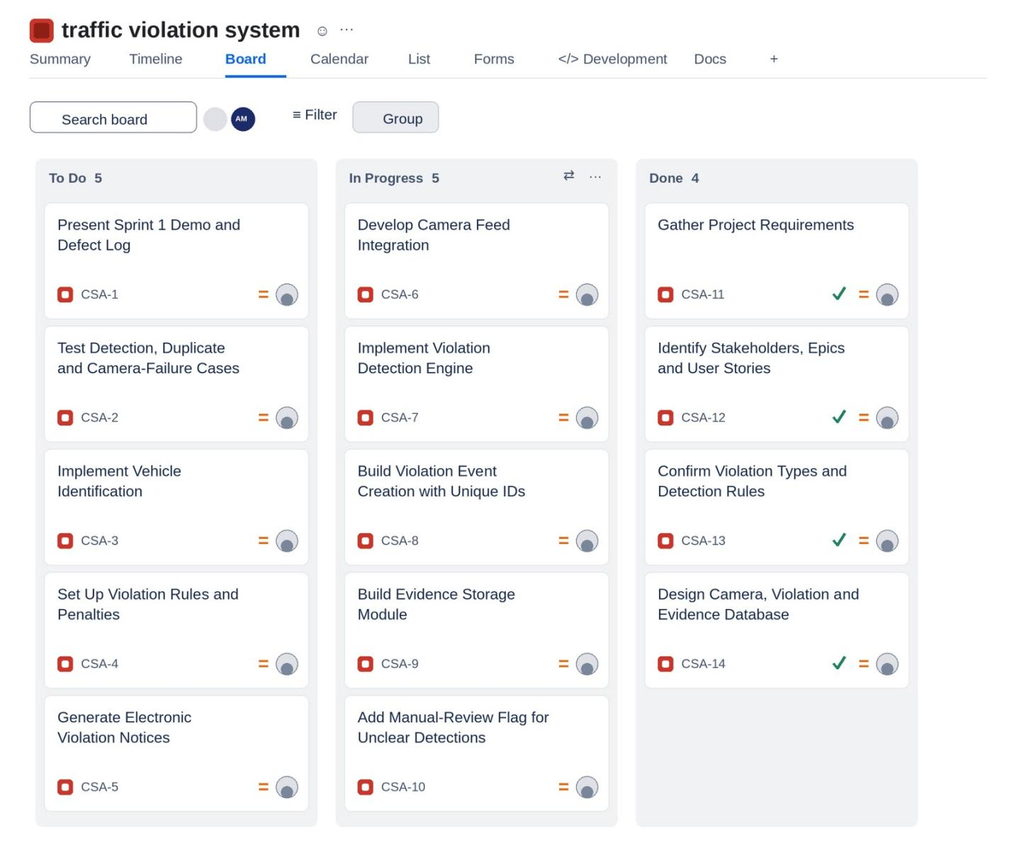
Rubrics for Calculation
Criteria | Excellent (5 Marks) | Good (3 Marks) | Satisfactory (2 Marks) | Needs Improvement (1 Mark)
Project Vision & Stakeholder Identification (30%) | Project vision is clear, comprehensive, and aligned with the problem statement. All relevant stakeholders and their roles are correctly identified. | Vision is clear with minor omissions. Most stakeholders are correctly identified. | Vision is partially defined. Some stakeholders are missing or incorrectly identified. | Vision is unclear or incomplete. Stakeholders are poorly identified or missing.
Epics & User Stories (25%) | Epics are well-defined and user stories are complete, follow Agile format, and fully capture functional requirements. | Epics and user stories are mostly complete with minor formatting or requirement issues. | User stories are partially complete with limited Agile structure. | User stories are incomplete, unclear, or do not follow Agile practices.
Acceptance Criteria (20%) | Acceptance criteria are specific, measurable, testable, and aligned with all user stories. | Acceptance criteria are mostly clear and testable with minor gaps. | Acceptance criteria are partially defined and lack clarity or completeness. | Acceptance criteria are missing or not aligned with user stories.
Product Backlog Prioritization & Sprint Planning (15%) | Product backlog is logically prioritized, sprint backlog is realistic, and task breakdown is complete. | Backlog prioritization and sprint planning are mostly appropriate with minor issues. | Prioritization or sprint planning is partially complete with limited justification. | Backlog prioritization and sprint planning are poorly organized or incomplete.
Story Point Estimation, Sprint Goal & Presentation (10%) | Story point estimation is well justified, sprint goal is clear, deliverables are realistic, and presentation is professional and well organized. | Estimation and sprint goal are mostly appropriate with minor inconsistencies. Presentation is clear. | Estimation or sprint goal lacks justification. Presentation is adequate but incomplete. | Estimation is unrealistic or missing. Sprint goal, deliverables, and presentation are unclear or incomplete.

Criteria | Mark
Project Vision & Stakeholder Identification (30%) | /5
Epics & User Stories (25%) | /5
Acceptance Criteria (20%) | /5
Product Backlog Prioritization & Sprint Planning (15%) | /5
Story Point Estimation, Sprint Goal & Presentation (10%) | /5
TOTAL | /25

